Client requesting the server:
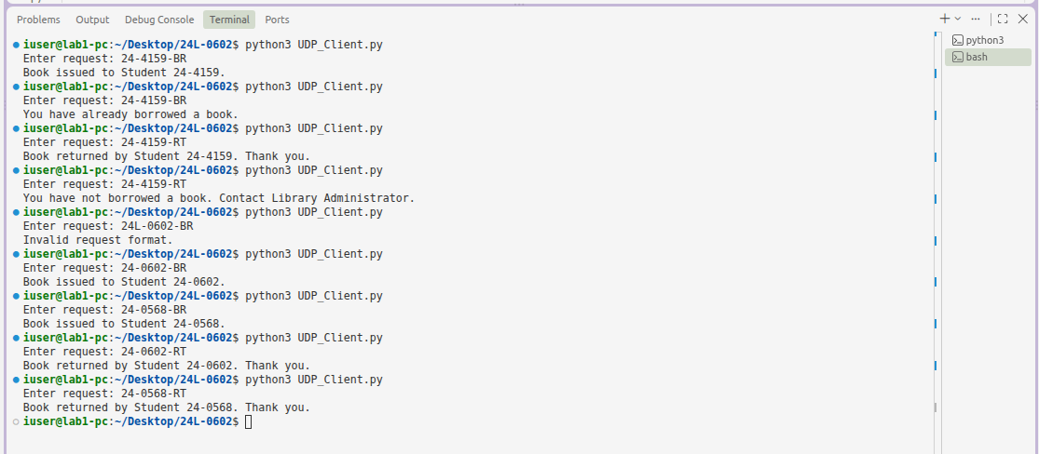
- SUCCESSFUL BORROW
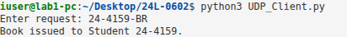
- SUCCESSFUL RETURN
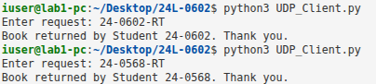
- DUPLICATE BORROW
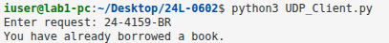
- RETURN WITHOUT BORROWING
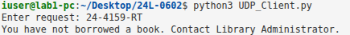

SERVER SIDE OF REQUEST:
- MULTIPLE REQUESTS WITHOUR RESTART:
